# Hatch timing tool (M14)

## Aims

M14. Cesar. Develop regional RLEM hatch date grower tool to optimise monitoring for RLEM pressure at crop emergence. Validate this tool using early-season field collections that infer hatch date from the oldest life-stage observed.

## Brief methods

We extended a previous study on predicting hatch dates from regional temperature and rainfall conditions [(McDonald et al. 2015)](https://paperpile.com/c/eiwucZ/wHCO) to an easy-to-use web interface that will provide the predicted hatch date for a user-defined location. This includes an option for real-time weather data for the current growing season, or long-term average conditions.

After completion of a draft interface, feedback from end-users was sought through a webinar and focus group at a GRDC grower network meeting. Facilitated by Belinda Cay, using the Group Map elicitation software (Appendix 2) several questions were posed to the group to provide direction for future development of the tools so that it will best meet the needs of growers.

1. Would an accurate forecast of hatch date help your monitoring and management activities?
2. Under what circumstances would you use such a tool?
3. Would you prefer such tools to be integrated with other digital ag services (e.g. Agworld, Back Paddock, Planfarm) or with grains management resources (e.g. GRDC website and/or Cesar PestNotes?)
4. What other improvements or considerations can you suggest to improve usefulness to growers?

The full feedback is available in Appendix 2. In summary, some users thought the tools would help target monitoring, particularly in high-risk situations, but there was a large appreciation of the role of prophylactic treatments (seed treatments, bare earth sprays, and tank mixes) that was seen as a barrier to monitoring based management approach. Other users called for more information on mite abundance at hatching (see Seasonal risk forecaster M13). In terms of interfaces, some users thought it might be more convenient to integrate with other digital ag platforms (e.g., AgWorld), while other users (particularly independent advisers) thought a standalone tool would be preferable. In any case, a timely reminder of the availability of such tools was seen to be useful (e.g., through seasonal industry updates). Integration of additional pests and linking to other resources and tools was suggested.

The new tool was also promoted through various communication channels including SARDI pestfacts and PestFacts south-eastern.

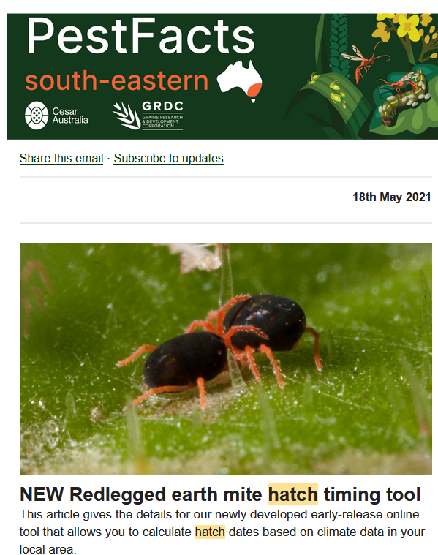

**Figure.** Example of RLEM hatch tool promotion in 2021.

To validate the predictions, on 17 June 2022, during the period of predicted mite hatching, we compared predicted hatch times with observed hatch times across different climatic zones.

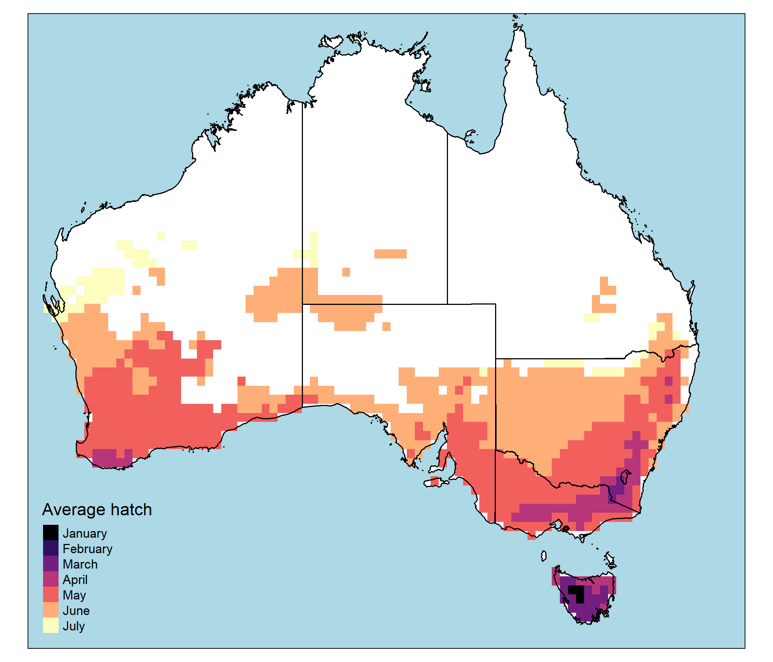

**Figure.** The mean predicted hatch month for different climatic regions in Australia using gridded climatic data spanning the 20 years from 1996-2015.

We sampled along two roadside transects running from north to south into higher rainfall zones in Victorian grain growing regions. The first transect spanned Stoneleigh to Bendigo, Vic with randomly selected locations separated by ~10 km. The second transect spanned Lockington to Ararat, Vic with samples separated by ~20 km.

Mites at each sample point were collected from suitable vegetation along roadsides within 20 m from the car adjacent to grain crops and pastures using vacuum sampling. Mites were sampled until at least 50 mites had been accumulated, which was usually achieved with one sample (~20 seconds of vacuuming). If no mites were found, mites were marked as absent, which only occurred in one sample.

The collected mites were funnelled into Eppendorf Tubes® with 70% ethanol. The following day, 50 randomly selected RLEM spread onto a white plate and categorised into their life-stage with a dissecting microscope using the morphological description of Baker (1995) [<https://www.tandfonline.com/doi/abs/10.1080/01647959508684069>].

Following McDonald et al. (2015), the hatch date was estimated by counting back from the collection dateby the estimated duration from hatching until the observed life stage, i.e., development times for larva, protonymph, deutonymph, tritonymph, and adult, were taken as 2, 6, 11, 16, and 21 days, respectively. Additional hatch dates found from a literature search conducted by McDonald et al. (2015) were also included in the analysis resulting in 25 samples from the present study and 15 samples from the literature review.

## Results and outcomes to date

### Model validation

Comparison of the observed hatch dates with predicted hatch dates revealed that the model error was no more than 15 days across all samples, with a mean error (and s.e.) of -4.68 (4.03) days. The negative bias suggests that the model tended to overpredict the hatch dates. This bias may be useful, as mites would be difficult to observe within the first few days of hatching due to their small size. Even in the case of the largest error of 15 days, mites are unlikely to have reached their most economically injurious life stage (i.e., the adult phase), which should allow sufficient time for intervention where necessary. The sample locations and prediction errors for each site are shown in the plots below (Figure)

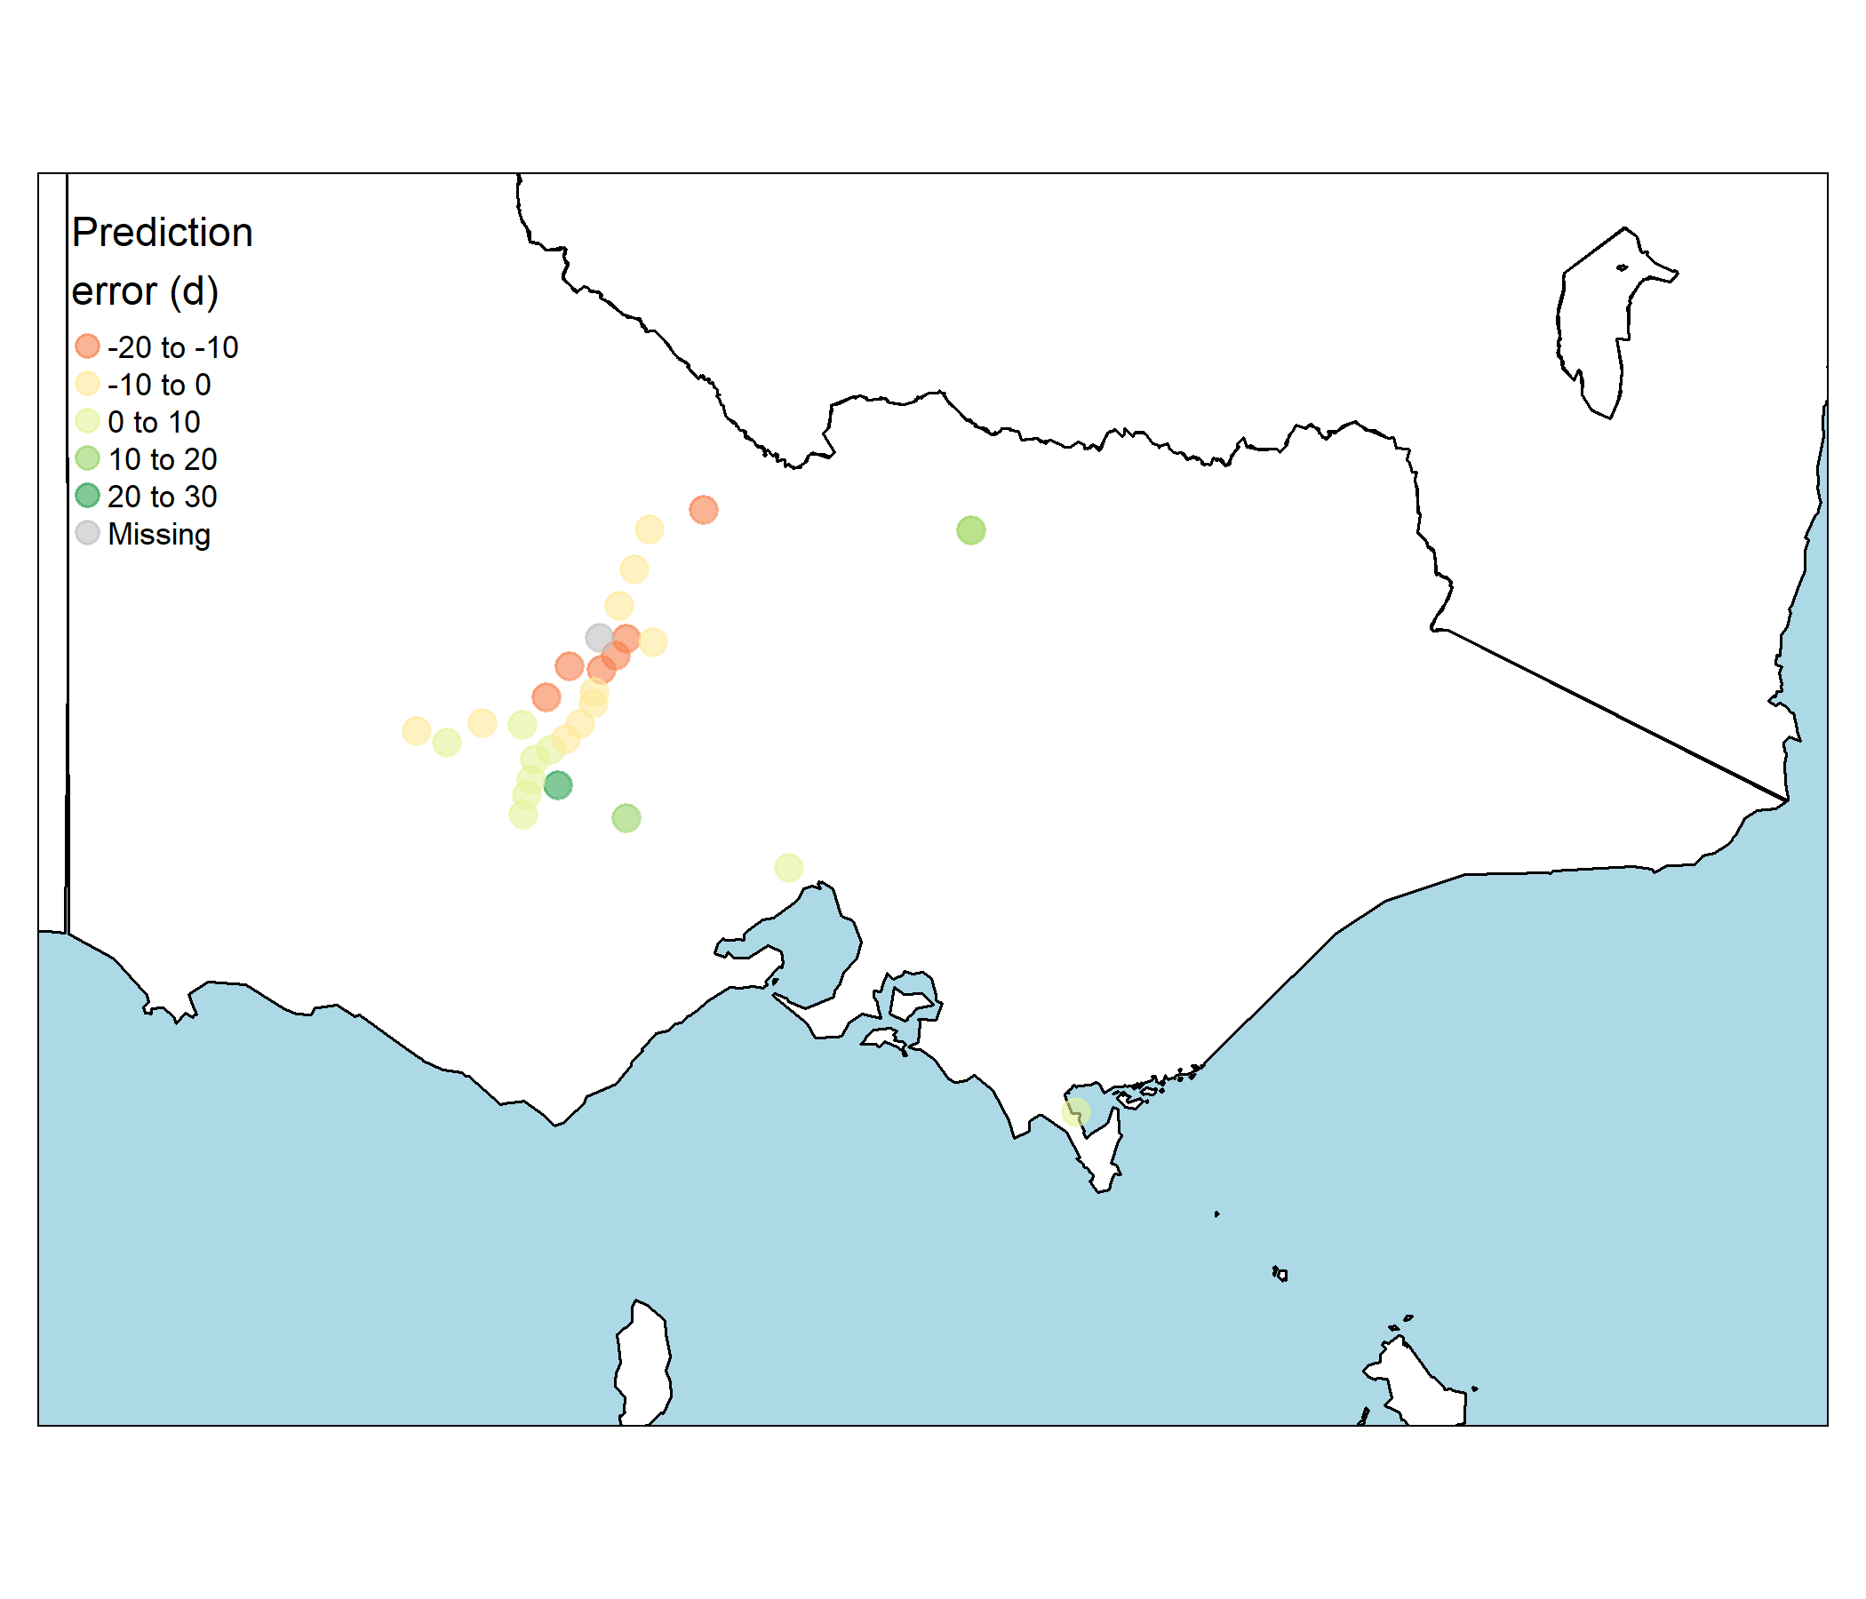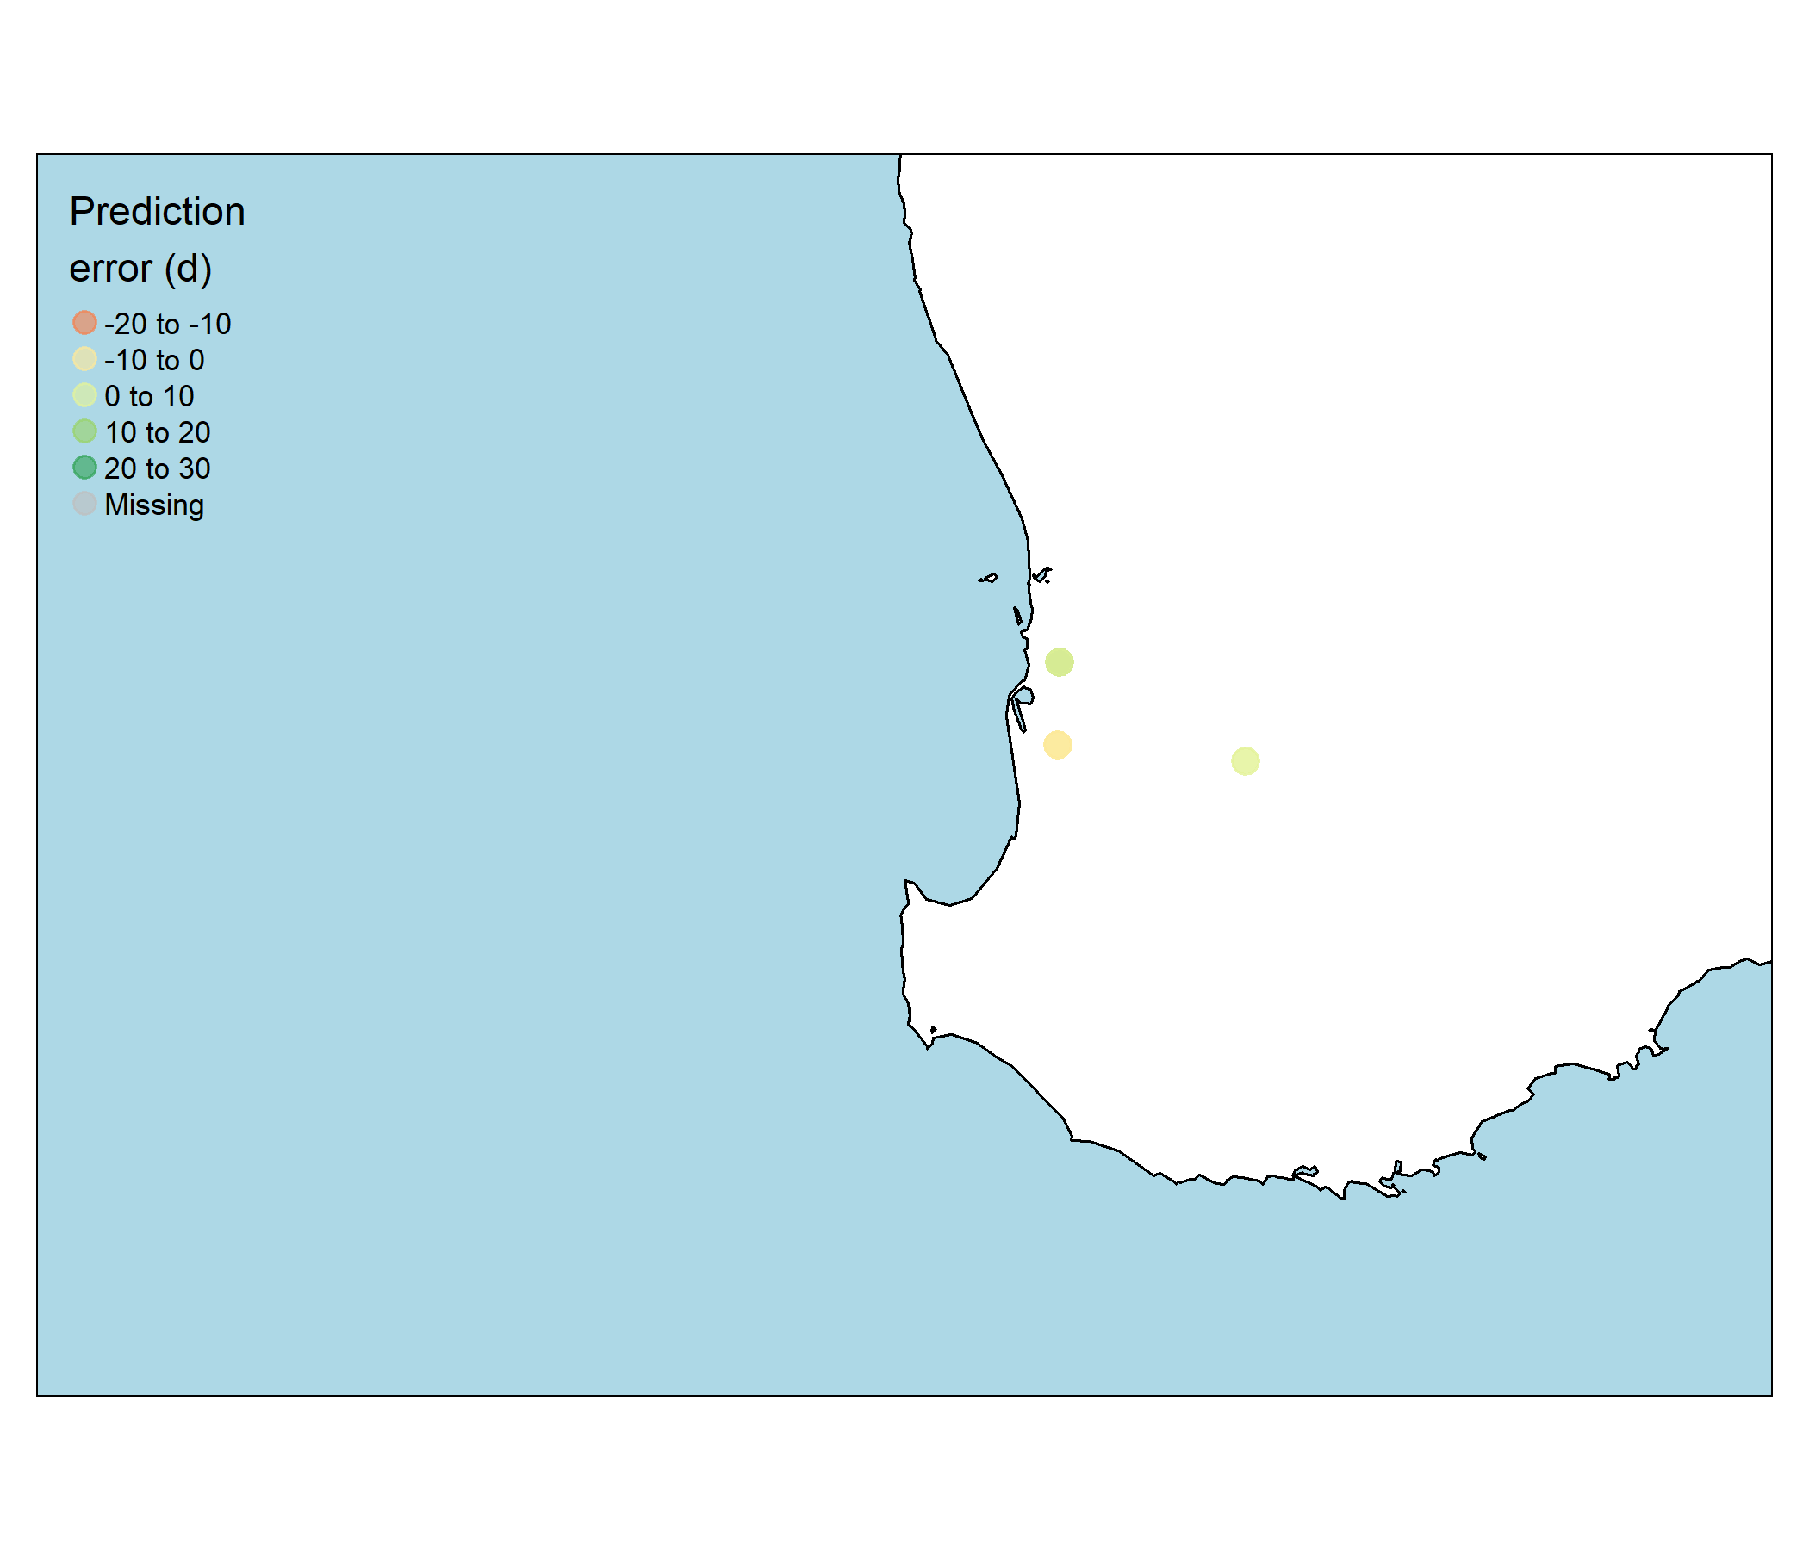

**Figure.** A total of 40 samples (with one site with no mites found) were included as part of the RLEM hatch model validation.

### Web application and user-interface

The final version of the hatch tool is available online at <https://cesaraustralia.shinyapps.io/RLEM-hatch/> (see figure below). Following feedback from end users the app has been optimised for a variety of screen sizes (phone, tablet, laptop) and can be embedded as an interactive panel in online digital communications (e.g. PestFacts articles) around the time of monitoring and relevant management decisions.

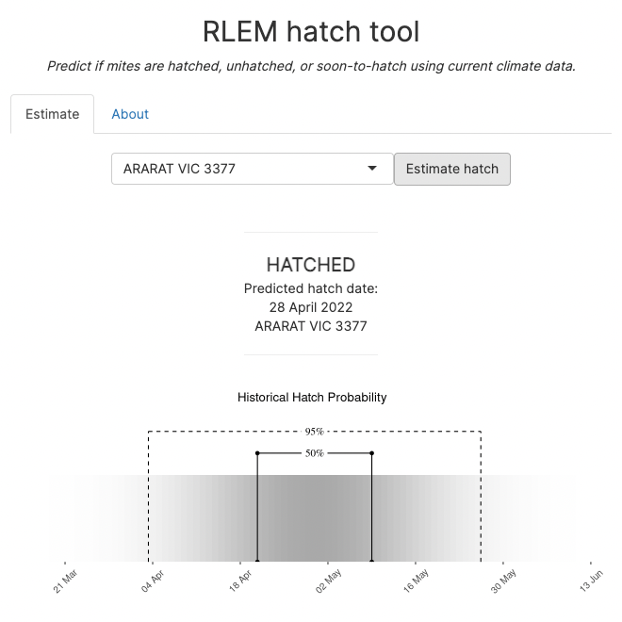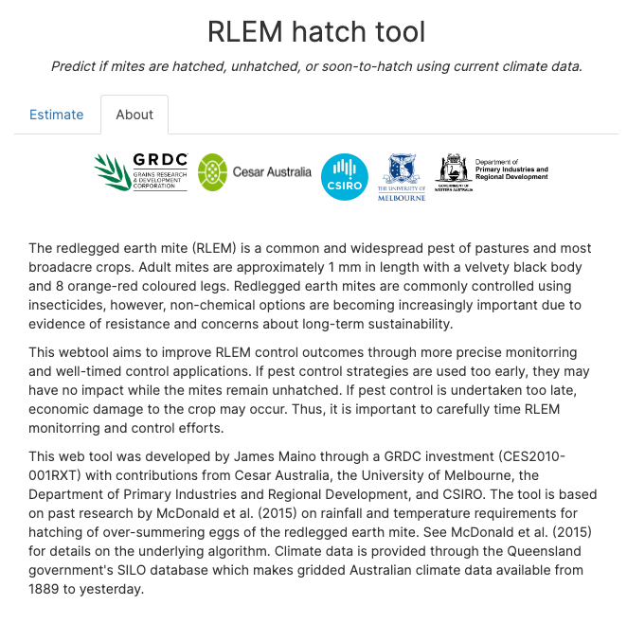

**FIgure 14.1** Location selector for hatch prediction webtool allows users to easily select their location of interest.

The app has two tabs, ‘Estimate’ and ‘About’. The ‘Estimate’ tab shows a simple output of the hatch estimate, while the ‘About’ tab show additional information, including current climatic data for the season up to the present date. Once temperature and rainfall conditions for the current season have been met, the hatch date will be indicated on the graph that shows local rainfall and temperature conditions according to the SILO climatic database (Figure below).

**Figure 14.2** Temperature and rainfall for the 2021 season in west Victoria are used to predict the hatch date for RLEM.

Users can access predicted hatch dates for their location across the last 25 years (Table below).

**Table.** Estimated date of hatch in west Victoria based on previous 25 years of climatic data. Chance of hatch represents the proportion of all years that were predicted to have hatched by the given date.

### Hatch prediction map

To help facilitate quick visualisation of regional RLEM hatch status we also developed an online mapped prediction for extension scientists. Due to the computational processing required for gridded estimates across the continent, the program is housed on amazon web services and is not intended to be made widely available to the public. Rather, extension scientists will be given access (http://13.54.70.163:3838/RLEM-hatch-map/), who can then easily share the mapped outputs through different means, including PestFacts or other industry extension outlets.

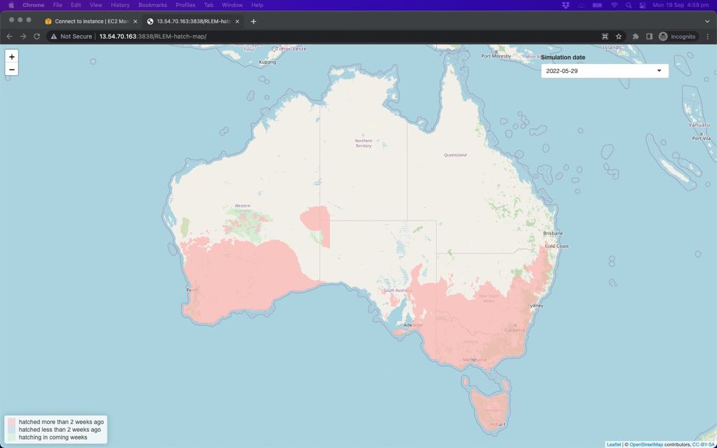

**Figure.** Mock up figure illustrating regional predictions of hatch likelihood based on the season’s climatic conditions. This map is available to extension scientists at the following link http://13.54.70.163:3838/RLEM-hatch-map/

# Appendix 2 - GroupMap feedback on draft RLEM hatch tool and seasonal risk forecaster tool

**Hatch tool feedback**

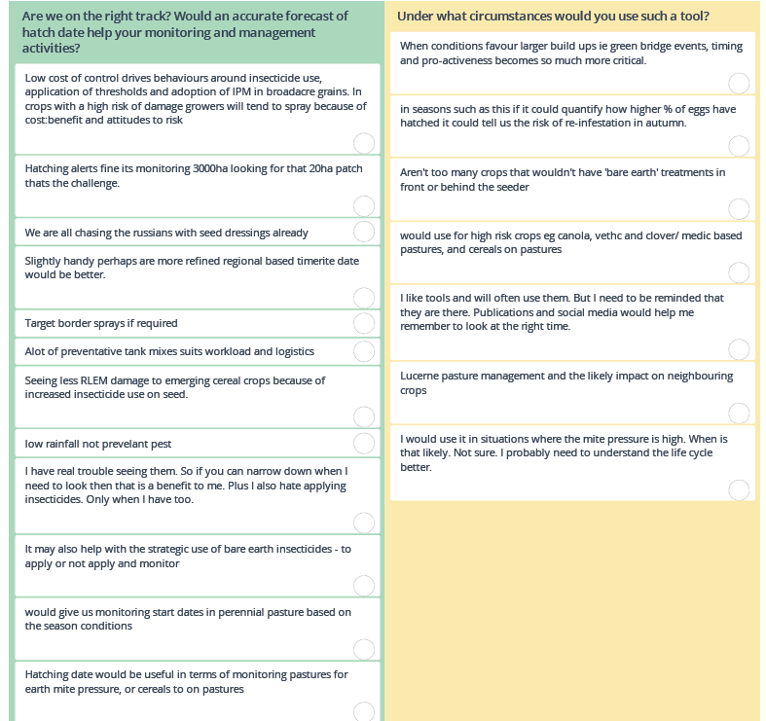

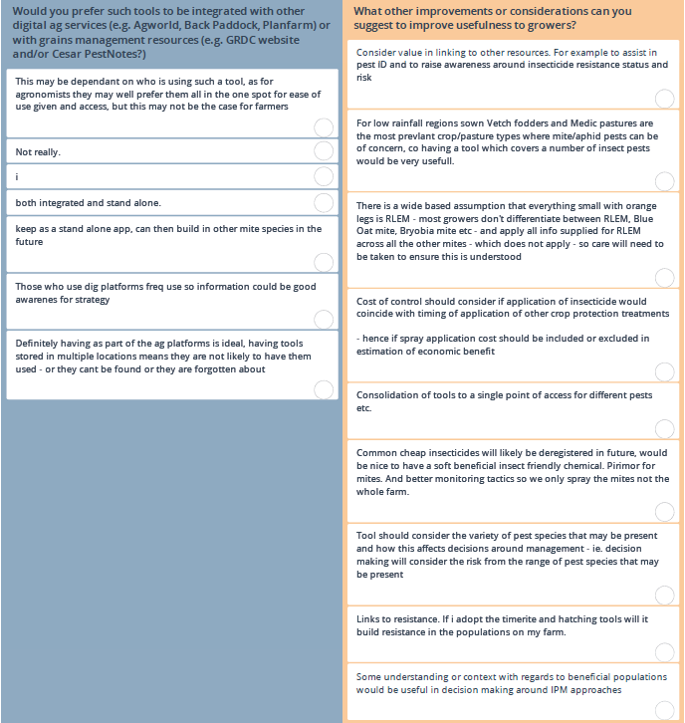

**Seasonal risk and cost-benefit tool feedback**

